PRACTICAL – 1A
AIM: Create a simple Calculator application using a Servlet.
Index.html
<!DOCTYPE html>
<html lang="en">
<head>
<meta charset="UTF-8">
<title>Calculator App</title>
</head>
<body>
<h2>Calculator </h2>
<p>Name: SHEKHAR SUMAN</p>
<p>Roll No: 47</p>
<form action="CalculatorServlet" method="get">
<label>
Enter First Number:
<input type="text" name="txtN1" required>
</label>
<br><br>

<label>
Enter Second Number:
<input type="text" name="txtN2" required>
</label>
<br><br>

<p>Select an Operation:</p>
<label><input type="radio" name="opr" value="+" required> Addition</label><br>
<label><input type="radio" name="opr" value="-"> Subtraction</label><br>
<label><input type="radio" name="opr" value="*"> Multiplication</label><br>
<label><input type="radio" name="opr" value="/"> Division</label><br><br>

<input type="reset" value="Clear">
<input type="submit" value="Calculate">
</form>
</body>
</html>

CalculatorServlet.java
import jakarta.servlet.ServletException;
import jakarta.servlet.annotation.WebServlet;
import jakarta.servlet.http.HttpServlet;
import jakarta.servlet.http.HttpServletRequest;
import jakarta.servlet.http.HttpServletResponse;
import java.io.*;

@WebServlet("/CalculatorServlet")
public class CalculatorServlet extends HttpServlet {

@Override
public void doGet(HttpServletRequest request, HttpServletResponse response)
throws ServletException, IOException {

response.setContentType("text/html;charset=UTF-8");
PrintWriter out = response.getWriter();

out.println("<html><head><title>Calculator Result</title></head><body>");

try {
double n1 = Double.parseDouble(request.getParameter("txtN1"));
double n2 = Double.parseDouble(request.getParameter("txtN2"));
String opr = request.getParameter("opr");

double result = 0;
String operation = "";

if (opr.equals("+")) {
result = n1 + n2;
operation = "Addition";
} else if (opr.equals("-")) {
result = n1 - n2;
operation = "Subtraction";
} else if (opr.equals("*")) {
result = n1 * n2;
operation = "Multiplication";
} else if (opr.equals("/")) {
if (n2 != 0) {
result = n1 / n2;
operation = "Division";
} else {
out.println("<h3>Error: Division by zero is not allowed.</h3>");
out.println("</body></html>");
return;
}
}

out.println("<h2>Operation: " + operation + "</h2>");
out.println("<h2>Result = " + result + "</h2>");

} catch (NumberFormatException e) {
out.println("<h3>Error: Please enter valid numbers.</h3>");
}

out.println("</body></html>");
}
}

OUTPUT
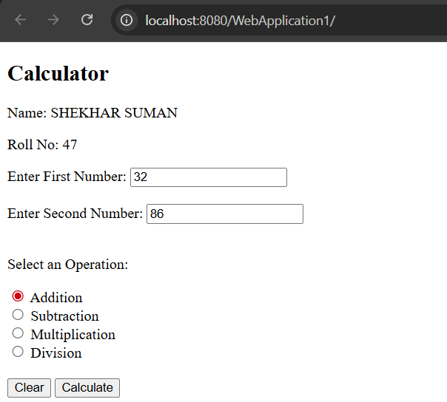

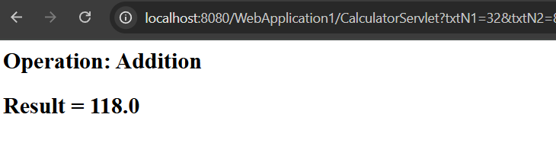

PRACTICAL – 1B
AIM: Create a servlet for a login page. If the username and password are correct then it says message "Hello <username>" else a message "login failed"
Index.html
<!DOCTYPE html>
<html>
<head>
<title>Login Form</title>
</head>
<body>
<form action="LoginServlet" method="post">
<label for="txtId">Enter User ID</label>
<input type="text" id="txtId" name="txtId"><br><br>

<label for="txtPass">Enter Password</label>
<input type="password" id="txtPass" name="txtPass"><br><br>

<input type="reset" value="Reset">
<input type="submit" value="Click to Login">
</form>
</body>
</html>

LoginServlet.java
import java.io.*;
import jakarta.servlet.*;
import jakarta.servlet.http.*;
import jakarta.servlet.annotation.WebServlet;

@WebServlet("/LoginServlet")
public class LoginServlet extends HttpServlet {

@Override
protected void doPost(HttpServletRequest request, HttpServletResponse response)
throws ServletException, IOException {

response.setContentType("text/html;charset=UTF-8");
PrintWriter out = response.getWriter();

String uname = request.getParameter("txtId"); // user ID
String upass = request.getParameter("txtPass"); // password

out.println("<html><head><title>Servlet LoginServlet</title></head>");

if ("Shekhar Suman".equals(uname) && "12345".equals(upass)) {
out.println("<body bgcolor='blue'>");
out.println("<h1>Welcome !!! " + uname + "</h1>");
} else {
out.println("<body bgcolor='red'>");
out.println("<h1>Login Fail !!!</h1>");
}

out.println("</body></html>");
}
}

OUTPUT

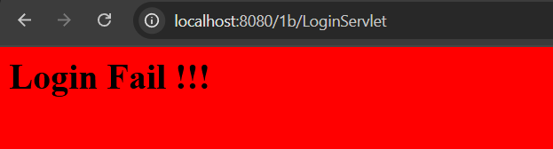
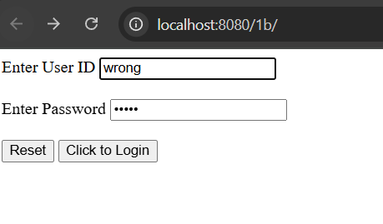
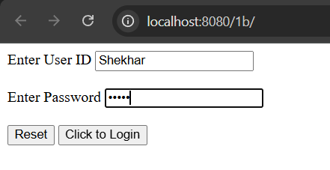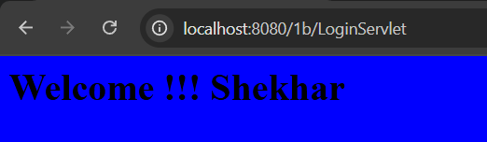
PRACTICAL – 1C
AIM: Create a registration Servlet in Java using JDBC. Accept the details such as Username, Password, Email, and Country from the user using HTML Form and store the registration details in the database.
Index.html
<!DOCTYPE html>
<html>
<head>
<meta charset="UTF-8">
<title>Registration Page</title>
</head>
<body>
<h1>Registration Page by SHEKHAR SUMAN</h1>

<form action="RegisterServlet" method="post">
<label for="username">Enter User Name:</label>
<input type="text" id="username" name="username"><br><br>

<label for="password">Enter Password:</label>
<input type="password" id="password" name="password"><br><br>

<label for="email">Enter Email:</label>
<input type="email" id="email" name="email"><br><br>

<label for="country">Enter Country:</label>
<input type="text" id="country" name="country"><br><br>

<input type="reset" value="Reset">
<input type="submit" value="REGISTER">
</form>
</body>
</html>

RegisterServlet.java
import jakarta.servlet.ServletException;
import jakarta.servlet.annotation.WebServlet;
import jakarta.servlet.http.HttpServlet;
import jakarta.servlet.http.HttpServletRequest;
import jakarta.servlet.http.HttpServletResponse;
import java.io.*;
import java.sql.*;

@WebServlet("/RegisterServlet")
public class RegisterServlet extends HttpServlet {

@Override
public void doPost(HttpServletRequest request, HttpServletResponse response)
throws ServletException, IOException {

response.setContentType("text/html;charset=UTF-8");
PrintWriter out = response.getWriter();

// Read form parameters
String id = request.getParameter("username");
String ps = request.getParameter("password");
String em = request.getParameter("email");
String co = request.getParameter("country");

try {
// Load Driver
Class.forName("com.mysql.cj.jdbc.Driver");

// Connect to Database
Connection con = DriverManager.getConnection(
"jdbc:mysql://localhost:3306/sr", "root", "test");

// Insert into DB
PreparedStatement pst = con.prepareStatement("INSERT INTO user VALUES (?,?,?,?)");
pst.setString(1, id);
pst.setString(2, ps);
pst.setString(3, em);
pst.setString(4, co);

int row = pst.executeUpdate();

if (row > 0) {
out.println("<h1>Record Inserted Successfully!</h1>");
} else {
out.println("<h1>Failed to Insert Record.</h1>");
}

pst.close();
con.close();

} catch (Exception e) {
out.println("<h1>Error: " + e.getMessage() + "</h1>");
}
}
}

DATABASE
-- Create database
CREATE DATABASE sr;

-- Use the database
USE sr;

-- Create user table
CREATE TABLE users (
Username VARCHAR(20) PRIMARY KEY,
Password VARCHAR(20),
Email VARCHAR(50),
Country VARCHAR(20)
);

INSERT INTO users VALUES ('admin', 'admin', 'admin@admin.com', 'India');
SELECT * FROM users;

OUTPUT
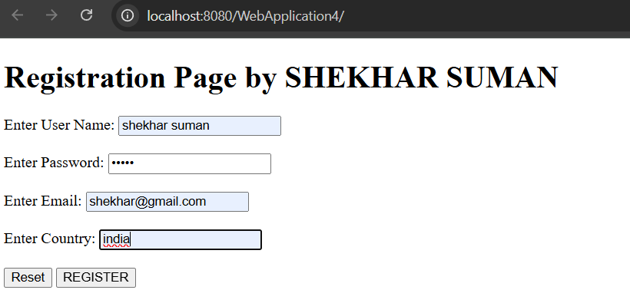
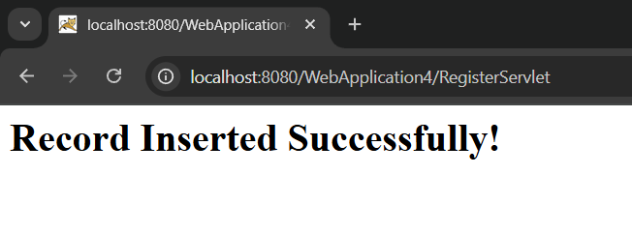

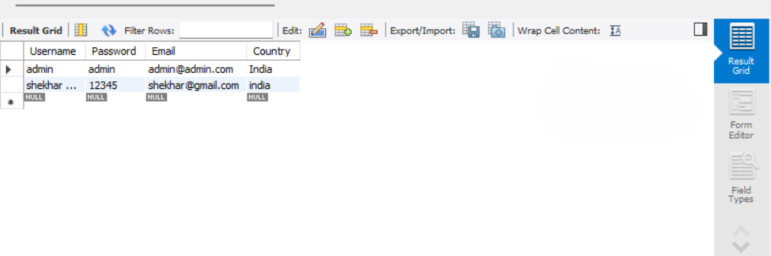

PRACTICAL – 2A
AIM: Using Request Dispatcher Interface create a Servlet which will validate the password entered by the user, if the user has entered “Servlet” as password, then he will be forwarded to Welcome Servlet else the user will stay on the index.html page and an error message will be displayed.
Index.html
<!DOCTYPE html>
<html>
<head>
<title>Login Form</title>
</head>
<body>

<form action="LoginServlet" method="get">
<div>
<h2>SHEKHAR SUMAN | 47</h2>
<label for="txtId">Enter User ID</label>
<input type="text" id="txtId" name="txtId">
</div>

<div>
<label for="txtPass">Enter Password</label>
<input type="password" id="txtPass" name="txtPass">
</div>

<input type="reset" value="Clear">
<input type="submit" value="Login">
</form>

</body>
</html>

LoginServlet.java

import jakarta.servlet.RequestDispatcher;
import jakarta.servlet.ServletException;
import jakarta.servlet.annotation.WebServlet;
import jakarta.servlet.http.HttpServlet;
import jakarta.servlet.http.HttpServletRequest;
import jakarta.servlet.http.HttpServletResponse;
import java.io.IOException;
import java.io.PrintWriter;

@WebServlet("/LoginServlet")
public class LoginServlet extends HttpServlet {

@Override
protected void doPost(HttpServletRequest request, HttpServletResponse response)
throws ServletException, IOException {
processRequest(request, response);
}

@Override
protected void doGet(HttpServletRequest request, HttpServletResponse response)
throws ServletException, IOException {
processRequest(request, response);
}

private void processRequest(HttpServletRequest request, HttpServletResponse response)
throws ServletException, IOException {

response.setContentType("text/html;charset=UTF-8");
PrintWriter out = response.getWriter();

String uname = request.getParameter("txtId");
String upass = request.getParameter("txtPass");

if ("admin".equals(uname) && "servlet".equals(upass)) {
RequestDispatcher rd = request.getRequestDispatcher("WelcomeServlet");
rd.forward(request, response);
} else {
out.println("<body bgcolor='red'>");
out.println("<h1>Login Failed !!!</h1>");
out.println("<h2>SHEKHAR SUMAN | 47</h2>");
RequestDispatcher rd = request.getRequestDispatcher("index.html");
rd.include(request, response);
out.println("</body>");
}
}
}

WelcomeServlet.java

import jakarta.servlet.ServletException;
import jakarta.servlet.annotation.WebServlet;
import jakarta.servlet.http.HttpServlet;
import jakarta.servlet.http.HttpServletRequest;
import jakarta.servlet.http.HttpServletResponse;
import java.io.IOException;
import java.io.PrintWriter;

@WebServlet("/WelcomeServlet")
public class WelcomeServlet extends HttpServlet {

@Override
public void doGet(HttpServletRequest request, HttpServletResponse response)
throws ServletException, IOException {

response.setContentType("text/html;charset=UTF-8");
PrintWriter out = response.getWriter();

out.println("<html><head>");
out.println("<title>Welcome</title></head>");
out.println("<body bgcolor='lightgreen'>");
out.println("<h1> Welcome SHEKHAR SUMAN | 47 ! Login Successful ✅ </h1>");
out.println("</body></html>");
}
}

OUTPUT
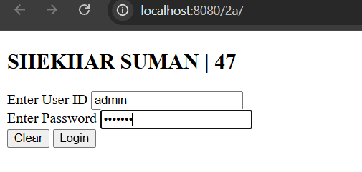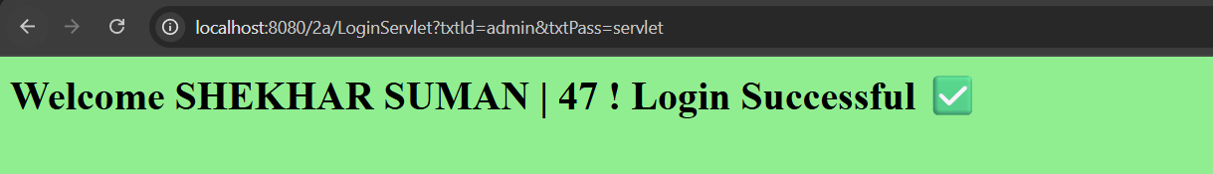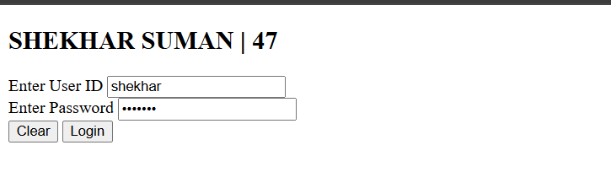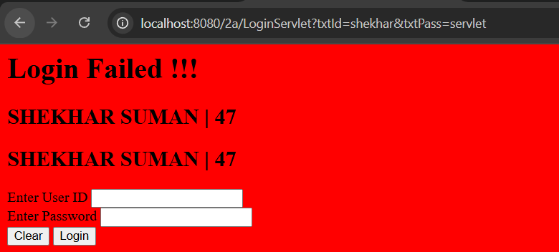
PRACTICAL – 2B
AIM: Create a Servlet that uses Cookies to store the number of times a user has visited Servlet.
Index.html

<!DOCTYPE html>
<html>
<head>
<title>Cookie Demo</title>
</head>
<body>
<form action="Page1" method="get">
Enter Your Name: <input type="text" name="txtName"><br><br>
<input type="submit" value="~~~ Click to Enter ~~~">
</form>
</body>
</html>

Page1.java
import jakarta.servlet.ServletException;
import jakarta.servlet.annotation.WebServlet;
import jakarta.servlet.http.Cookie;
import jakarta.servlet.http.HttpServlet;
import jakarta.servlet.http.HttpServletRequest;
import jakarta.servlet.http.HttpServletResponse;
import java.io.*;
import java.net.URLEncoder;

@WebServlet("/Page1")
public class Page1 extends HttpServlet {

@Override
public void doGet(HttpServletRequest request, HttpServletResponse response)
throws ServletException, IOException {

response.setContentType("text/html;charset=UTF-8");
PrintWriter out = response.getWriter();

String uname = request.getParameter("txtName");

// If username not provided, use default
if (uname == null || uname.trim().isEmpty()) {
uname = "Guest";
}

String encodedName = URLEncoder.encode(uname, "UTF-8");

// Create cookies
Cookie ck1 = new Cookie("username", encodedName);
Cookie ck2 = new Cookie("visit", "1");
response.addCookie(ck1);
response.addCookie(ck2);

// HTML output
out.println("<html>");
out.println("<head><title>Page1</title></head>");
out.println("<body bgcolor='pink'>");
out.println("<h1>~~~ Welcome " + uname + " ~~~</h1>");
out.println("<h1><a href='Page2'>Click to visit Page 2</a></h1>");
out.println("</body>");
out.println("</html>");
}
}

Page2.java
import jakarta.servlet.ServletException;
import jakarta.servlet.annotation.WebServlet;
import jakarta.servlet.http.Cookie;
import jakarta.servlet.http.HttpServlet;
import jakarta.servlet.http.HttpServletRequest;
import jakarta.servlet.http.HttpServletResponse;
import java.io.*;
import java.net.URLDecoder;

@WebServlet("/Page2")
public class Page2 extends HttpServlet {

@Override
public void doGet(HttpServletRequest request, HttpServletResponse response)
throws ServletException, IOException {

response.setContentType("text/html;charset=UTF-8");
PrintWriter out = response.getWriter();

out.println("<html><head><title>Page2</title></head>");
out.println("<body bgcolor='yellow'>");

Cookie[] ck = request.getCookies();
if (ck != null) {
for (int i = 0; i < ck.length; i++) {
if (ck[i].getName().equals("visit")) {
int count = Integer.parseInt(ck[i].getValue()) + 1;
out.println("<h1>Visit No: " + count + "</h1>");
ck[i] = new Cookie("visit", count + "");
response.addCookie(ck[i]);
} else if (ck[i].getName().equals("username")) {
String decodedName = URLDecoder.decode(ck[i].getValue(), "UTF-8");
out.println("<h2>User: " + decodedName + "</h2>");
}
}
}

out.println("<h1><a href='Page3'>Click to visit Page 3</a></h1>");
out.println("<h1><a href='Page4'>Click to visit Page 4</a></h1>");
out.println("<h1><a href='Page5'>Click to visit Page 5</a></h1>");

out.println("</body></html>");
}
}

Page3.java

import jakarta.servlet.ServletException;
import jakarta.servlet.annotation.WebServlet;
import jakarta.servlet.http.Cookie;
import jakarta.servlet.http.HttpServlet;
import jakarta.servlet.http.HttpServletRequest;
import jakarta.servlet.http.HttpServletResponse;
import java.io.*;
import java.net.URLDecoder;

@WebServlet("/Page3")
public class Page3 extends HttpServlet {

@Override
public void doGet(HttpServletRequest request, HttpServletResponse response)
throws ServletException, IOException {

response.setContentType("text/html;charset=UTF-8");
PrintWriter out = response.getWriter();

out.println("<html><head><title>Page3</title></head>");
out.println("<body bgcolor='lightgreen'>");

Cookie[] ck = request.getCookies();
if (ck != null) {
for (int i = 0; i < ck.length; i++) {
if (ck[i].getName().equals("visit")) {
int count = Integer.parseInt(ck[i].getValue()) + 1;
out.println("<h1>Visit No: " + count + "</h1>");
ck[i] = new Cookie("visit", count + "");
response.addCookie(ck[i]);
} else if (ck[i].getName().equals("username")) {
String decodedName = URLDecoder.decode(ck[i].getValue(), "UTF-8");
out.println("<h2>User: " + decodedName + "</h2>");
}
}
}

out.println("<h1><a href='Page4'>Click to visit Page 4</a></h1>");
out.println("<h1><a href='Page5'>Click to visit Page 5</a></h1>");
out.println("<h1><a href='Page1'>Back to Page 1</a></h1>");

out.println("</body></html>");
}
}

Page4.java

import java.io.IOException;
import java.io.PrintWriter;
import jakarta.servlet.ServletException;
import jakarta.servlet.annotation.WebServlet;
import jakarta.servlet.http.Cookie;
import jakarta.servlet.http.HttpServlet;
import jakarta.servlet.http.HttpServletRequest;
import jakarta.servlet.http.HttpServletResponse;
import java.net.URLDecoder;

@WebServlet("/Page4")
public class Page4 extends HttpServlet {

@Override
public void doGet(HttpServletRequest request, HttpServletResponse response)
throws ServletException, IOException {

response.setContentType("text/html;charset=UTF-8");
PrintWriter out = response.getWriter();

out.println("<html><head><title>Page4</title></head>");
out.println("<body bgcolor='orange'>");

Cookie[] ck = request.getCookies();
if (ck != null) {
for (int i = 0; i < ck.length; i++) {
if (ck[i].getName().equals("visit")) {
int count = Integer.parseInt(ck[i].getValue()) + 1;
out.println("<h1>Visit No: " + count + "</h1>");
ck[i] = new Cookie("visit", count + "");
response.addCookie(ck[i]);
} else if (ck[i].getName().equals("username")) {
String decodedName = URLDecoder.decode(ck[i].getValue(), "UTF-8");
out.println("<h2>User: " + decodedName + "</h2>");
}
}
}

out.println("<h1><a href='Page5'>Click to visit Page 5</a></h1>");
out.println("<h1><a href='Page1'>Back to Page 1</a></h1>");

out.println("</body></html>");
}
}

Page5.java
import java.io.IOException;
import java.io.PrintWriter;
import jakarta.servlet.ServletException;
import jakarta.servlet.annotation.WebServlet;
import jakarta.servlet.http.Cookie;
import jakarta.servlet.http.HttpServlet;
import jakarta.servlet.http.HttpServletRequest;
import jakarta.servlet.http.HttpServletResponse;
import java.net.URLDecoder;

@WebServlet("/Page5")
public class Page5 extends HttpServlet {

@Override
public void doGet(HttpServletRequest request, HttpServletResponse response)
throws ServletException, IOException {

response.setContentType("text/html;charset=UTF-8");
PrintWriter out = response.getWriter();

out.println("<html><head><title>Page5</title></head>");
out.println("<body bgcolor='lightblue'>");

Cookie[] ck = request.getCookies();
if (ck != null) {
for (int i = 0; i < ck.length; i++) {
if (ck[i].getName().equals("visit")) {
int count = Integer.parseInt(ck[i].getValue()) + 1;
out.println("<h1>Visit No: " + count + "</h1>");
ck[i] = new Cookie("visit", count + "");
response.addCookie(ck[i]);
} else if (ck[i].getName().equals("username")) {
String decodedName = URLDecoder.decode(ck[i].getValue(), "UTF-8");
out.println("<h2>User: " + decodedName + "</h2>");
}
}
}

out.println("<h1><a href='Page1'>Back to Page 1</a></h1>");
out.println("<h1><a href='Page2'>Back to Page 2</a></h1>");

out.println("</body></html>");
}
}

OUTPUT
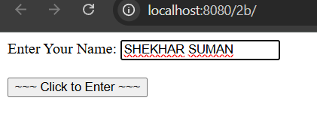
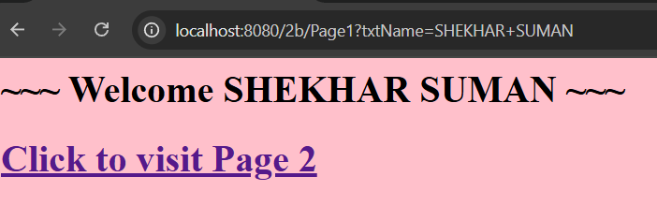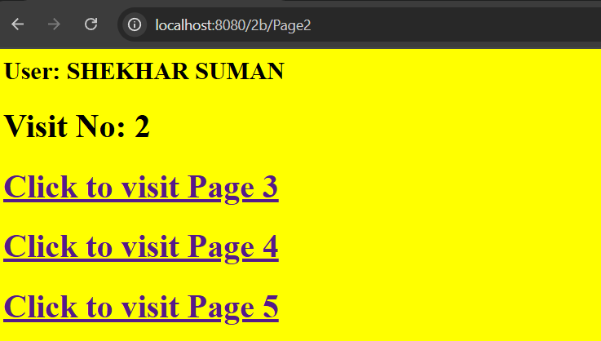

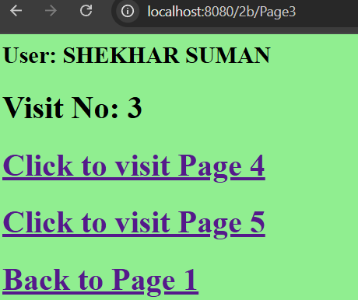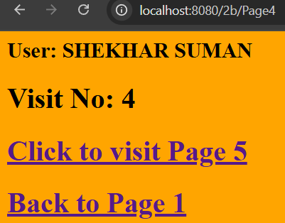

PRACTICAL – 2C
AIM: Create a Servlet demonstrating the use of session creation and destruction. Also check whether the user has visited this page first time or has visited earlier also using Sessions.
Index.html
<!DOCTYPE html>
<html>
<head>
<title>Session Demo</title>
</head>
<body bgcolor="lightgrey">
<h1>Session Tracking Demo</h1>
<form action="Page1" method="get">
Enter User ID: <input type="text" name="txtName" required><br><br>
<input type="reset" value="Reset">
<input type="submit" value="Submit">
</form>
</body>
</html>
LogoutServlet.java
import java.io.*;
import jakarta.servlet.*;
import jakarta.servlet.annotation.WebServlet;
import jakarta.servlet.http.*;

@WebServlet("/LogoutServlet")
public class LogoutServlet extends HttpServlet {

@Override
public void doGet(HttpServletRequest request, HttpServletResponse response)
throws ServletException, IOException {

response.setContentType("text/html;charset=UTF-8");
PrintWriter out = response.getWriter();

out.println("<html><head><title>Logout</title></head>");
out.println("<body bgcolor='lightgrey'>");

// Get the session; if exists, invalidate
HttpSession hs = request.getSession(false);
if (hs != null) {
hs.invalidate();
}

out.println("<h1>You are logged out successfully.</h1>");
out.println("<h2><a href='index.html'>Go back to Login Page</a></h2>");

out.println("</body></html>");
}
}

Page1.java
import java.io.*;
import jakarta.servlet.*;
import jakarta.servlet.annotation.WebServlet;
import jakarta.servlet.http.*;

@WebServlet("/Page1")
public class Page1 extends HttpServlet {

@Override
public void doGet(HttpServletRequest request, HttpServletResponse response)
throws ServletException, IOException {

response.setContentType("text/html;charset=UTF-8");
PrintWriter out = response.getWriter();

out.println("<html><head><title>Servlet Page1</title></head>");
out.println("<body bgcolor='yellow'>");

HttpSession hs = request.getSession(true);

if (hs.isNew()) {
String name = request.getParameter("txtName");
hs.setAttribute("uname", name);
hs.setAttribute("visit", "1");

out.println("<h1>Welcome First Time, " + name + "</h1>");
} else {
out.println("<h1>Welcome Again</h1>");
int visit = Integer.parseInt((String) hs.getAttribute("visit")) + 1;
hs.setAttribute("visit", String.valueOf(visit));
out.println("<h1>You Visited " + visit + " Times</h1>");
}

out.println("<h2><a href='Page2'>Go to Page 2</a></h2>");
out.println("<h2><a href='LogoutServlet'>Terminate Session</a></h2>");
out.println("</body></html>");
}
}

Page2.java
import java.io.*;
import jakarta.servlet.*;
import jakarta.servlet.annotation.WebServlet;
import jakarta.servlet.http.*;

@WebServlet("/Page2")
public class Page2 extends HttpServlet {

@Override
public void doGet(HttpServletRequest request, HttpServletResponse response)
throws ServletException, IOException {

response.setContentType("text/html;charset=UTF-8");
PrintWriter out = response.getWriter();

out.println("<html><head><title>Servlet Page2</title></head>");
out.println("<body bgcolor='lightblue'>");

HttpSession hs = request.getSession(false);

if (hs == null) {
out.println("<h1>No active session. Please <a href='index.html'>login again</a>.</h1>");
} else {
int visit = Integer.parseInt((String) hs.getAttribute("visit")) + 1;
hs.setAttribute("visit", String.valueOf(visit));

out.println("<h1>Welcome Again, " + hs.getAttribute("uname") + "</h1>");
out.println("<h1>You Visited " + visit + " Times</h1>");
out.println("<h1>Your Session ID: " + hs.getId() + "</h1>");
out.println("<h1>You Logged in at: " + new java.util.Date(hs.getCreationTime()) + "</h1>");
}

out.println("<h2><a href='Page1'>Back to Page 1</a></h2>");
out.println("<h2><a href='Page3'>Go to Page 3</a></h2>");
out.println("<h2><a href='Page4'>Go to Page 4</a></h2>");
out.println("<h2><a href='LogoutServlet'>Terminate Session</a></h2>");

out.println("</body></html>");
}
}

Page3.java
import java.io.*;
import jakarta.servlet.*;
import jakarta.servlet.annotation.WebServlet;
import jakarta.servlet.http.*;

@WebServlet("/Page3")
public class Page3 extends HttpServlet {

@Override
public void doGet(HttpServletRequest request, HttpServletResponse response)
throws ServletException, IOException {

response.setContentType("text/html;charset=UTF-8");
PrintWriter out = response.getWriter();

out.println("<html><head><title>Servlet Page3</title></head>");
out.println("<body bgcolor='lightgreen'>");

HttpSession hs = request.getSession(false);

if (hs == null) {
out.println("<h1>No active session. Please <a href='index.html'>login again</a>.</h1>");
} else {
int visit = Integer.parseInt((String) hs.getAttribute("visit")) + 1;
hs.setAttribute("visit", String.valueOf(visit));
String uname = (String) hs.getAttribute("uname");

out.println("<h1>Welcome " + uname + " to Page 3</h1>");
out.println("<h1>You Visited " + visit + " Times</h1>");
out.println("<h1>Session ID: " + hs.getId() + "</h1>");
out.println("<h1>Session Created At: " + new java.util.Date(hs.getCreationTime()) + "</h1>");
}

out.println("<h2><a href='Page1'>Go to Page 1</a></h2>");
out.println("<h2><a href='Page2'>Go to Page 2</a></h2>");
out.println("<h2><a href='Page4'>Go to Page 4</a></h2>");
out.println("<h2><a href='Page5'>Go to Page 5</a></h2>");
out.println("<h2><a href='LogoutServlet'>Terminate Session</a></h2>");

out.println("</body></html>");
}
}

Page4.java
import java.io.*;
import jakarta.servlet.*;
import jakarta.servlet.annotation.WebServlet;
import jakarta.servlet.http.*;

@WebServlet("/Page4")
public class Page4 extends HttpServlet {

public void doGet(HttpServletRequest request, HttpServletResponse response)
throws ServletException, IOException {

response.setContentType("text/html;charset=UTF-8");
PrintWriter out = response.getWriter();

out.println("<html><head><title>Servlet Page4</title></head>");
out.println("<body bgcolor=orange>");

HttpSession hs = request.getSession(false);

if (hs == null) {
out.println("<h1>No active session. Please <a href=index.html>login again</a>.</h1>");
} else {
int visit = Integer.parseInt((String) hs.getAttribute("visit")) + 1;
hs.setAttribute("visit", String.valueOf(visit));
String uname = (String) hs.getAttribute("uname");

out.println("<h1>Welcome " + uname + " to Page 4</h1>");
out.println("<h1>You Visited " + visit + " Times</h1>");
out.println("<h1>Session ID: " + hs.getId() + "</h1>");
}

out.println("<h2><a href=Page1>Go to Page 1</a></h2>");
out.println("<h2><a href=Page2>Go to Page 2</a></h2>");
out.println("<h2><a href=Page3>Go to Page 3</a></h2>");
out.println("<h2><a href=Page5>Go to Page 5</a></h2>");
out.println("<h2><a href=LogoutServlet>Terminate Session</a></h2>");

out.println("</body></html>");
}
}

Page5.java
import java.io.*;
import jakarta.servlet.*;
import jakarta.servlet.annotation.WebServlet;
import jakarta.servlet.http.*;

@WebServlet("/Page5")
public class Page5 extends HttpServlet {

public void doGet(HttpServletRequest request, HttpServletResponse response)
throws ServletException, IOException {

response.setContentType("text/html;charset=UTF-8");
PrintWriter out = response.getWriter();

out.println("<html><head><title>Servlet Page5</title></head>");
out.println("<body bgcolor=lightblue>");

HttpSession hs = request.getSession(false);

if (hs == null) {
out.println("<h1>No active session. Please <a href=index.html>login again</a>.</h1>");
} else {
int visit = Integer.parseInt((String) hs.getAttribute("visit")) + 1;
hs.setAttribute("visit", String.valueOf(visit));
String uname = (String) hs.getAttribute("uname");

out.println("<h1>Welcome " + uname + " to Page 5</h1>");
out.println("<h1>You Visited " + visit + " Times</h1>");
out.println("<h1>Session ID: " + hs.getId() + "</h1>");
}

out.println("<h2><a href=Page1>Go to Page 1</a></h2>");
out.println("<h2><a href=Page2>Go to Page 2</a></h2>");
out.println("<h2><a href=Page3>Go to Page 3</a></h2>");
out.println("<h2><a href=Page4>Go to Page 4</a></h2>");
out.println("<h2><a href=LogoutServlet>Terminate Session</a></h2>");
out.println("</body></html>");
}
}

OUTPUT
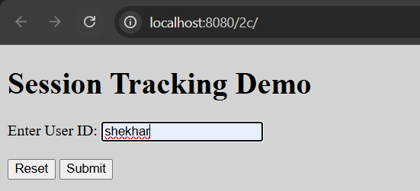

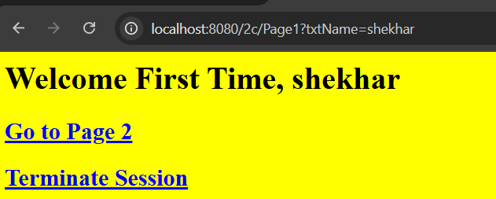

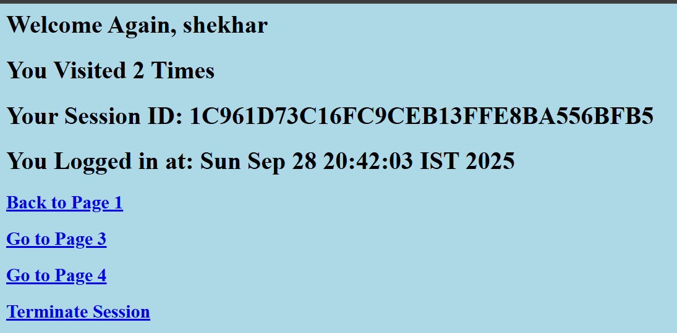

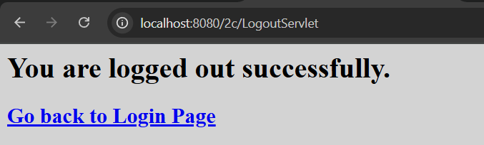

PRACTICAL – 3B
AIM: Develop Simple Servlet Question Answer Application using Database.

Index.html
<!DOCTYPE html>
<html lang="en">
<head>
<meta charset="UTF-8">
<title>Quiz Application</title>
<style>
body {
font-family: Arial, sans-serif;
text-align: center;
margin-top: 100px;
}
h1 {
color: #333;
}
a {
display: inline-block;
padding: 12px 24px;
background-color: #007BFF;
color: white;
text-decoration: none;
font-size: 18px;
border-radius: 6px;
}
a:hover {
background-color: #0056b3;
}
</style>
</head>
<body>
<h1>Welcome to Quiz Servlet by SHEKHAR SUMAN</h1>
<a href="QuizServlet">CLICK TO START QUIZ</a>
</body>
</html>

QuizServlet.java
import jakarta.servlet.ServletException;
import jakarta.servlet.annotation.WebServlet;
import jakarta.servlet.http.HttpServlet;
import jakarta.servlet.http.HttpServletRequest;
import jakarta.servlet.http.HttpServletResponse;

import java.io.IOException;
import java.io.PrintWriter;
import java.sql.Connection;
import java.sql.DriverManager;
import java.sql.ResultSet;
import java.sql.Statement;

@WebServlet("/QuizServlet")
public class QuizServlet extends HttpServlet {

@Override
public void doGet(HttpServletRequest request, HttpServletResponse response)
throws ServletException, IOException {

response.setContentType("text/html;charset=UTF-8");
PrintWriter out = response.getWriter();

out.println("<html><head><title>Quiz</title></head><body>");
out.println("<h1>Welcome to the Quiz!</h1>");
out.println("<form action='ShowResult' method='post'>"); // Use POST for form submission

try {
// Load MySQL Driver
Class.forName("com.mysql.cj.jdbc.Driver");

// Connect to Database (replace password if needed)
Connection con = DriverManager.getConnection(
"jdbc:mysql://localhost:3306/qadb", "root", "test");

Statement stmt = con.createStatement();
ResultSet res = stmt.executeQuery("SELECT * FROM quiz");

out.println("<table border='1' cellpadding='10'>");

int qno = 0;
while (res.next()) {
qno++;

// Question
out.println("<tr><td colspan='2'><b>Q" + qno + ". " + res.getString("Question") + "</b></td></tr>");

// Options
out.println("<tr><td><input type='radio' name='" + qno + "' value='"
+ res.getString("Op1") + "'></td><td>" + res.getString("Op1") + "</td></tr>");

out.println("<tr><td><input type='radio' name='" + qno + "' value='"
+ res.getString("Op2") + "'></td><td>" + res.getString("Op2") + "</td></tr>");

out.println("<tr><td><input type='radio' name='" + qno + "' value='"
+ res.getString("Op3") + "'></td><td>" + res.getString("Op3") + "</td></tr>");

out.println("<tr><td><input type='radio' name='" + qno + "' value='"
+ res.getString("Op4") + "'></td><td>" + res.getString("Op4") + "</td></tr>");
}

out.println("</table>");
out.println("<br><input type='reset'>");
out.println("<input type='submit' value='SUBMIT'>");

stmt.close();
con.close();

} catch (Exception e) {
out.println("<h1>Error: " + e.getMessage() + "</h1>");
}

out.println("</form></body></html>");
}
}

ShowResult.java
import java.io.*;
import java.sql.*;
import jakarta.servlet.*;
import jakarta.servlet.annotation.WebServlet;
import jakarta.servlet.http.*;

@WebServlet("/QuizServlet")
public class QuizServlet extends HttpServlet {

@Override
public void doGet(HttpServletRequest request, HttpServletResponse response)
throws ServletException, IOException {

response.setContentType("text/html;charset=UTF-8");
PrintWriter out = response.getWriter();

out.println("<form action='ShowResult' method='post'>");

try {
// Load MySQL Driver
Class.forName("com.mysql.cj.jdbc.Driver");

// Connect to Database
Connection con = DriverManager.getConnection(
"jdbc:mysql://localhost:3306/qadb", "root", "test");

Statement stmt = con.createStatement();
ResultSet res = stmt.executeQuery("SELECT * FROM quiz");

out.println("<table border='1' cellpadding='10'>");

int qno = 0;
while (res.next()) {
qno++;

// Question
out.println("<tr><td colspan='2'><b>Q" + qno + ". " + res.getString("question") + "</b></td></tr>");

// Options
out.println("<tr><td><input type='radio' name='" + qno + "' value='"
+ res.getString("op1") + "'></td><td>" + res.getString("op1") + "</td></tr>");

out.println("<tr><td><input type='radio' name='" + qno + "' value='"
+ res.getString("op2") + "'></td><td>" + res.getString("op2") + "</td></tr>");

out.println("<tr><td><input type='radio' name='" + qno + "' value='"
+ res.getString("op3") + "'></td><td>" + res.getString("op3") + "</td></tr>");

out.println("<tr><td><input type='radio' name='" + qno + "' value='"
+ res.getString("op4") + "'></td><td>" + res.getString("op4") + "</td></tr>");
}

out.println("</table>");
out.println("<br><input type='reset'>");
out.println("<input type='submit' value='SUBMIT'>");

stmt.close();
con.close();

} catch (Exception e) {
out.println("<h1>Error: " + e.getMessage() + "</h1>");
}

out.println("</form>");
}
}

DATABASE
CREATE DATABASE qadb;

USE qadb;

CREATE TABLE quiz (
Qno VARCHAR(5) PRIMARY KEY,
Question VARCHAR(150),
Op1 VARCHAR(50),
Op2 VARCHAR(50),
Op3 VARCHAR(50),
Op4 VARCHAR(50),
Ans VARCHAR(50)
);

INSERT INTO quiz VALUES
('001', 'What is the capital of India?', 'New Delhi', 'Kolkata', 'Chennai', 'Mumbai', 'New Delhi'),
('002', 'Who was the First President of India?', 'Dr. Rajendra Prasad', 'Dr. S. Radhakrishnan', 'Ram Nath Kovind', 'V. V. Giri', 'Dr. Rajendra Prasad'),
('003', 'What is ORM?', 'Object Ratio Mean', 'Object Rotation Measure', 'Object Relation Mapping', 'Oracle Management', 'Object Relation Mapping'),
('004', 'The unit of Energy is __', 'Dozen', 'Kilometer', 'Joule', 'Hertz', 'Joule'),
('005', '____ is the smallest memory unit.', 'Bit', 'Byte', 'Kilobyte', 'Gigabyte', 'Bit');

OUTPUT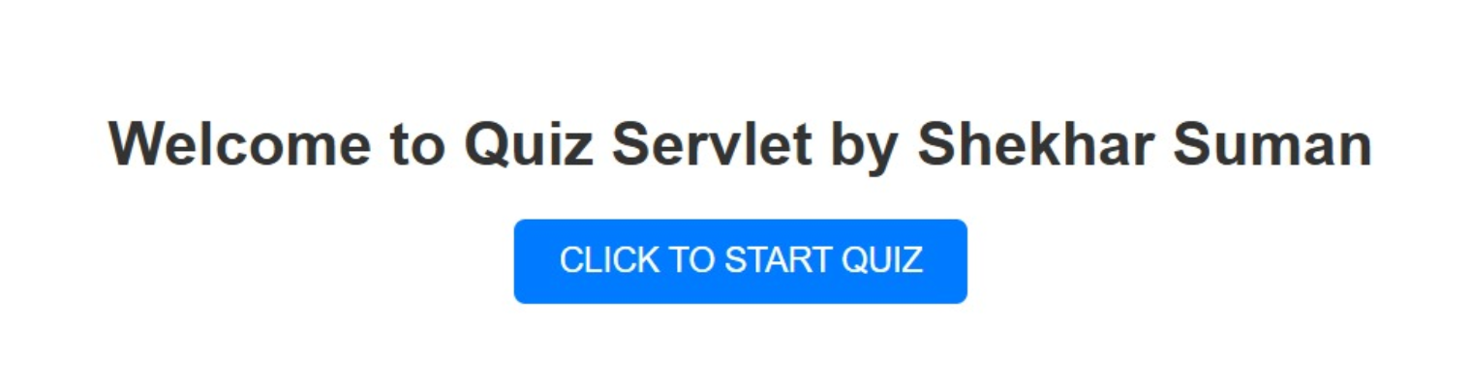
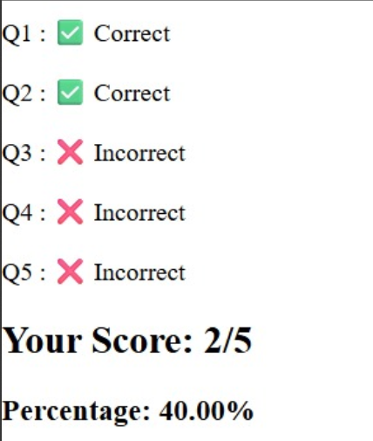
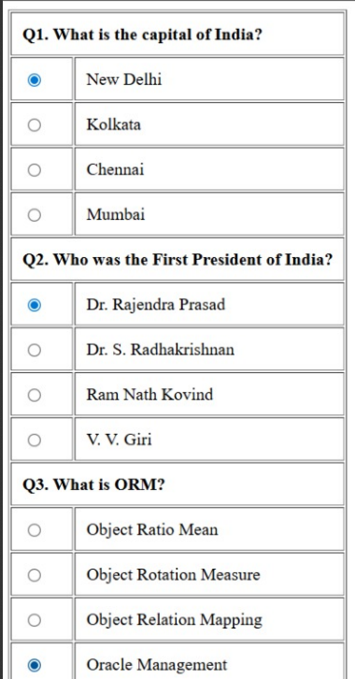
PRACTICAL – 4B
AIM: Develop a simple JSP application to pass values from one page to another with validations.

Index.html
<html>
<head>
<title>User Information Page</title>
</head>
<body>
<h2>Shekhar Suman </h2>
<form action="Validate.jsp">
Enter Your Name<input type="text" name="name" ><br>
Enter Your Age<input type="text" name="age" ><br>
Select Hobbies<input type="checkbox" name="hob" value="Singing">Singing
<input type="checkbox" name="hob" value="Reading">Reading Books
<input type="checkbox" name="hob" value="Football">Playing Football<br>
Enter E-mail<input type="text" name="email" ><br>
Select Gender<input type="radio" name="gender" value="male">Male
<input type="radio" name="gender" value="female">Female
<input type="radio" name="gender" value="other">Other<br>
<input type="hidden" name="error" value="">
<input type="submit" value="Submit Form">
</form> </body> </html>

Validate.jsp
<%@page contentType="text/html" pageEncoding="UTF-8" import="myPackage.*" %>
<!DOCTYPE html>
<html>
<head>
<title>Validation Page</title>
</head>
<body>
<jsp:useBean id="obj" scope="request" class="myPackage.CheckerBean" />
<jsp:setProperty name="obj" property="*" />

<% if (obj.validate()) { %>
<h2 style="color: green;">Validation Successful!</h2>
<p><strong>Name:</strong> <%= obj.getName() %></p>
<p><strong>Age:</strong> <%= obj.getAge() %></p>
<p><strong>Hobby:</strong> <%= obj.getHob() %></p>
<p><strong>Email:</strong> <%= obj.getEmail() %></p>
<p><strong>Gender:</strong> <%= obj.getGender() %></p>
<% } else { %>
<h2 style="color: red;">Validation Failed!</h2>
<div style="color: red; font-weight: bold;">
<%= obj.getError() %>
</div>
<br>
<a href="javascript:history.back()">Go Back</a>
<% } %>
</body>
</html>

CheckerBeam.java
package myPackage;
public class CheckerBean {
private String name, age, hob, email, gender, error;
public CheckerBean() {
error = "";
}
public void setName(String n) {
name = n;
}
public void setAge(String a) {
age = a;
}
public void setHob(String h) {
hob = h;
}
public void setEmail(String e) {
email = e;
}
public void setGender(String g) {
gender = g;
}
public void setError(String e) {
error = e;
}
public String getName() {
return name;
}
public String getAge() {
return age;
}
public String getHob() {
return hob;
}
public String getEmail() {
return email;
}
public String getGender() {
return gender;
}
public String getError() {
return error;
}

public boolean validate() {
boolean res = true

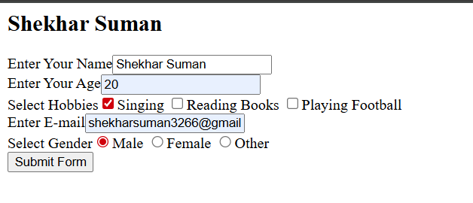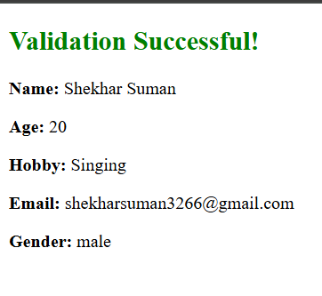

PRACTICAL – 4B
AIM: Create a registration and login JSP application to register and authenticate the user based on username and password using JDBC.

Index.html
<!DOCTYPE html>
<html>
<head>
<title>Authentication System</title>
</head>
<body>
<h2>Shekhar suman</h2>
<a href="Register.html"><u>New User Register Here</u></a>
<br><br>
<a href="Login.html"><u>Click Here to Login</u></a>
</body>
</html>
Register.html
<html>
<head>
<title>New User Registration Page</title>
</head>
<body>
<form action="Register.jsp" >
<h1> New User Registration Page</h1>
Enter User Name <input type="text" name="txtName" ><br>
Enter Password <input type="password" name="txtPass1" ><br>
Re-Enter Password<input type="password" name="txtPass2" ><br>
Enter Email<input type="text" name="txtEmail" ><br>
Enter Country Name <input type="text" name="txtCon" ><br>
<input type="reset" ><input type="submit" value="REGISTER" >
</form> </body> </html>

Login.html
<html><body>

<h1>Login Page</h1>
<form action="Login.jsp" >
Enter User Name <input type="text" name="txtName" ><br>
Enter Password <input type="password" name="txtPass" ><br>
<input type="reset" ><input type="submit" value="~~~LOGIN~~" >
</form></body></html>

Register.jsp
<%@page contentType="text/html" import="java.sql.*"%>
<html>
<body>
<h1>Registration JSP Page</h1>
<%
String uname = request.getParameter("txtName");
String pass1 = request.getParameter("txtPass1");
String pass2 = request.getParameter("txtPass2");
String email = request.getParameter("txtEmail");
String ctry = request.getParameter("txtCon");

if (pass1 != null && pass1.equals(pass2)) {
Connection con = null;
PreparedStatement stmt = null;
try {
Class.forName("com.mysql.cj.jdbc.Driver");
con = DriverManager.getConnection("jdbc:mysql://localhost:3306/logindb", "root", "test");

// Better: mention column names
stmt = con.prepareStatement("INSERT INTO user (Username, Password, Email, Country) VALUES (?,?,?,?)");
stmt.setString(1, uname);
stmt.setString(2, pass1);
stmt.setString(3, email);
stmt.setString(4, ctry);

int row = stmt.executeUpdate();
if (row == 1) {
out.println("<h2>Registration Successful</h2>");
} else {
out.println("<h2>Registration Failed</h2>");
%><jsp:include page="Register.html" /><%
}
} catch (Exception e) {
out.println("Error: " + e.getMessage());
} finally {
try { if (stmt != null) stmt.close(); } catch(Exception ex){}
try { if (con != null) con.close(); } catch(Exception ex){}
}
} else {
out.println("<h2>Password Mismatch</h2>");
%><jsp:include page="Register.html" /><%
}
%>
</body>
</html>
Login.jsp
<%@page contentType="text/html" import="java.sql.*"%>
<html>
<body>
<h1>Login JSP Page</h1>
<%
String uname = request.getParameter("txtName");
String pass = request.getParameter("txtPass");

Connection con = null;
PreparedStatement stmt = null;
ResultSet rs = null;

try {
Class.forName("com.mysql.cj.jdbc.Driver");
con = DriverManager.getConnection("jdbc:mysql://localhost:3306/logindb", "root", "test");

stmt = con.prepareStatement("SELECT Password FROM user WHERE Username=?");
stmt.setString(1, uname);
rs = stmt.executeQuery();

if (rs.next()) {
String dbPass = rs.getString("Password");
if (pass.equals(dbPass)) {
out.println("<h1>~~~ LOGIN SUCCESSFUL ~~~</h1>");
} else {
out.println("<h1>Incorrect Password!</h1>");
}
} else {
out.println("<h1>User does not exist!</h1>");
%><jsp:include page="Register.html" /><%
}

} catch (Exception e) {
out.println("Error: " + e.getMessage());
} finally {
try { if (rs != null) rs.close(); } catch(Exception ex) {}
try { if (stmt != null) stmt.close(); } catch(Exception ex) {}
try { if (con != null) con.close(); } catch(Exception ex) {}
}
%>
</body>
</html>

OUTPUT
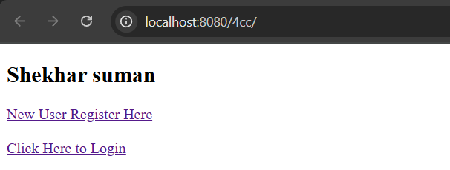
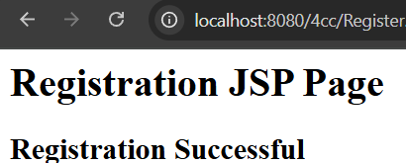
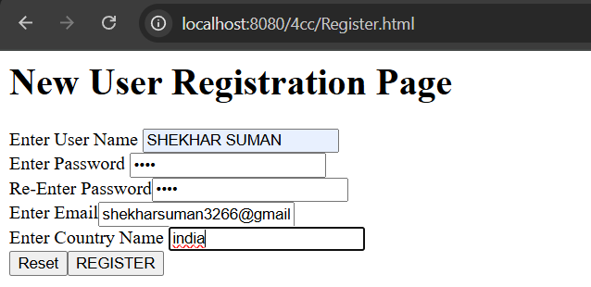

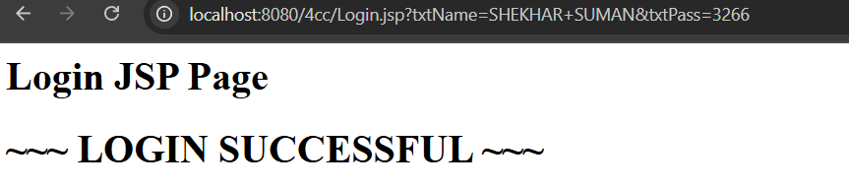
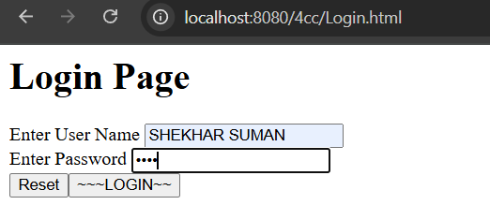

PRACTICAL – 5A
AIM: Create an html page with fields, eno, name, age, desg, salary. Now on submit this data to a JSP page which will update the employee table of database with matching eno.

Index.html
<!DOCTYPE html>
<html>
<head>
<title>Update Employee</title>
</head>
<body>
<h2>Update Employee Record by SHEKHAR SUMAN</h2>
<form action="updateEmployee.jsp" method="post">
<label>Employee No:</label>
<input type="text" name="eno" required><br><br>

<label>Name:</label>
<input type="text" name="name" required><br><br>

<label>Age:</label>
<input type="number" name="age" required><br><br>

<label>Designation:</label>
<input type="text" name="desg" required><br><br>

<label>Salary:</label>
<input type="number" name="salary" required><br><br>

<input type="submit" value="Update Employee">
</form>
</body>
</html>

updateEmployee.jsp
<%--
Document : updateEmployee
Created on : Sep 29, 2025, 8:33:29 PM
Author : SHEKHAR SUMAN
--%>

<%@ page contentType="text/html;charset=UTF-8" import="java.sql.*" %>
<html>
<head>
<title>Employee Update</title>
</head>
<body>
<%
String eno = request.getParameter("eno");
String name = request.getParameter("name");
String age = request.getParameter("age");
String desg = request.getParameter("desg");
String salary = request.getParameter("salary");

Connection con = null;
PreparedStatement ps = null;

try {
Class.forName("com.mysql.cj.jdbc.Driver");
con = DriverManager.getConnection("jdbc:mysql://localhost:3306/empinfo", "root", "test");

String sql = "UPDATE employee SET name=?, age=?, desg=?, salary=? WHERE eno=?";
ps = con.prepareStatement(sql);
ps.setString(1, name);
ps.setString(2, age);
ps.setString(3, desg);
ps.setString(4, salary);
ps.setString(5, eno);

int rows = ps.executeUpdate();

if (rows > 0) {
out.println("<h3>Employee record updated successfully!</h3>");
} else {
out.println("<h3>No employee found with ENO: " + eno + "</h3>");
}
} catch (Exception e) {
out.println("<h3>Error: " + e.getMessage() + "</h3>");
} finally {
if (ps != null) try { ps.close(); } catch (Exception ex) {}
if (con != null) try { con.close(); } catch (Exception ex) {}
}
%>
</body>
</html>

DATABASE
CREATE DATABASE empinfo;
USE empinfo;
CREATE TABLE employee (
eno VARCHAR(10) PRIMARY KEY,
name VARCHAR(50),
age INT,
desg VARCHAR(50),
salary DECIMAL(10,2)
);
INSERT INTO employee VALUES
('1', 'Shekhar', 23, 'Developer', 45000.00),
('2', 'Suman', 25, 'Tester', 38000.00),
('3', 'Shreyansh', 27, 'Manager', 60000.00),
('4', 'Alister', 29, 'Designer', 50000.00),
('5', 'Devraj', 26, 'Developer', 47000.00),
('6', 'Kirti', 24, 'Analyst', 42000.00);

DATABASE

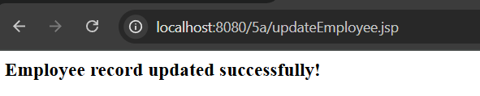
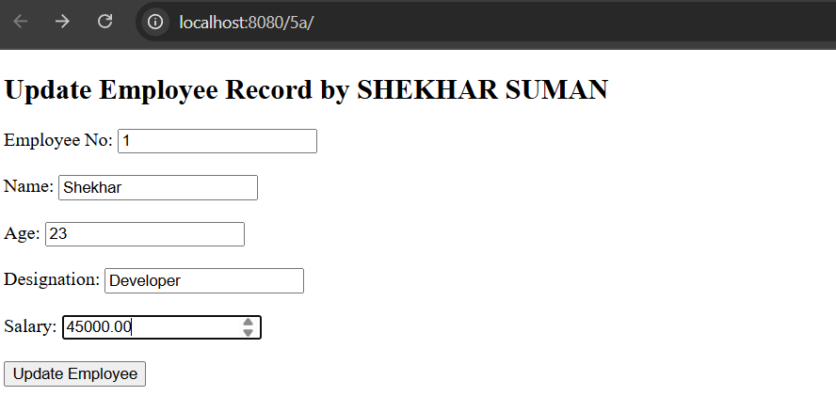

PRACTICAL – 6A
AIM: Create a Currency Converter application using EJB

Index.html
<!DOCTYPE html>
<html>
<head>
<title>Currency Converter</title>
</head>
<body>
index.html
<h2> Shekhar Suman </h2>
<form action="CCServlet">
Enter Amount <input type="text" name="amt"><br>
Select Conversion Type
<input type="radio" name="type" value="r2d" checked> Rupees to Dollar
<input type="radio" name="type" value="d2r"> Dollar to Rupees<br>
<input type="reset">
<input type="submit" value="CONVERT">
</form>
</body>
</html>

CCServlet.java
package mypack;

import java.io.*;
import javax.servlet.*;
import javax.servlet.http.*;
import javax.ejb.EJB;
import mybeans.CCBean;

public class CCServlet extends HttpServlet {

@EJB
CCBean obj;

public void doGet(HttpServletRequest request, HttpServletResponse response)
throws ServletException, IOException {

response.setContentType("text/html;charset=UTF-8");
PrintWriter out = response.getWriter();

double amt = Double.parseDouble(request.getParameter("amt"));

if (request.getParameter("type").equals("r2d")) {
out.println("<h1>" + amt + " Rupees = " + obj.r2Dollor(amt) + " Dollars</h1>");
}
if (request.getParameter("type").equals("d2r")) {
out.println("<h1>" + amt + " Dollars = " + obj.d2Rupees(amt) + " Rupees</h1>");
}
}
}

OUTPUT

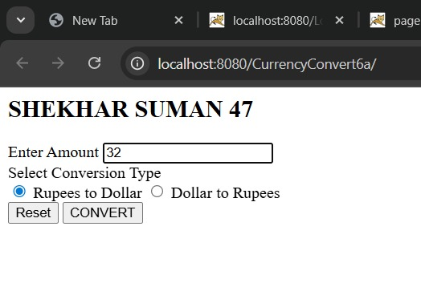

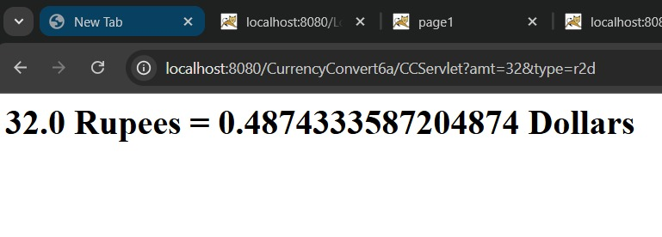

CERTIFICATE

Class: T.Y.B.Sc.I.T. |  | Year: 2025 - 2026
This is to certify that work entered in this Journal is the work of
Shri / Kumari: SHEKHAR SUMAN .
of T.Y.B.Sc.I.T division Roll No. 47 .
Uni. Exam No. . has satisfactorily completed the
Required number of practical and worked for the 5th Semester
Of the year 2025 - 2026 in the college laboratory as laid down
By the university.

Head of the | External | Internal Examiner
Department | Examiner | Subject teacher

Date:

NAME: SHEKHAR SUMAN |  | INDEX
CLASS: T.Y.B.Sc.I.T. | ROLL No: 47 | INDEX
SUBJECT: ENTERPRISE JAVA |  | INDEX
COLLEGE: ST. ROCK’S DEGREE COLLEGE |  | INDEX

PR No: | TITLE | DATE | SIGN
1A | Create a simple calculator application using servlet. | 03/07/2025
1B | Create a servlet for a login page. If the username and password are correct then it says message “Hello <username>” else a message “login failed”. | 17/07/2025
1C | Create a registration Servlet in Java using JDBC. Accept the details such as Username, Password, Email, and Country from the user using HTML Form and store the registration details in the database. | 31/07/2025
2A | Using Request Dispatcher Interface create a Servlet which will validate the password entered by the user, if the user has entered "Servlet" as password, then he will be forwarded to Welcome Servlet else the user will stay on the index.html page and an error message will be displayed. | 07/08/2025
2B | Create a Servlet that uses Cookies to store the number of times a user has visited Servlet. | 13/08/2025
2C | Create a Servlet demonstrating the use of session creation and destruction. Also check whether the user has visited this page first time or has visited earlier also using Sessions. | 21/08/2025
3B | Develop Simple Servlet Question Answer Application using Database. | 25/08/2025
4B | Develop a simple JSP application to pass values from one page to another with validations. | 04/09/2025
4C | Create a registration and login JSP application to register and authenticate the user based on username and password using JDBC. | 11/09/2025
5A | Create an html page with fields, eno, name, age, desg, salary. Now on submit this data to a JSP page which will update the employee table of database with matching eno. | 17/09/2025
6A | Create a Currency Converter application using EJB. | 25/09/2025

